Which of the following statements are true about a max-heap

Select one or more:

It is used to implement min-priority queue

The element stored at the root node will have the maximum value

The element stored at the root node will have the minimum value

It is used to implement max-priority queue

In the linked list representation of binary trees, nodes for which both left and right pointers are NULL are called as

Select one:

External nodes

Internal nodes

Root node

Parent node

A node in a tree that does not have a parent is called as a leaf

Select one:

True

False

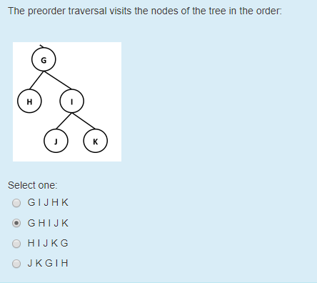

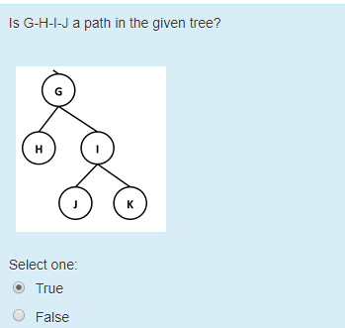

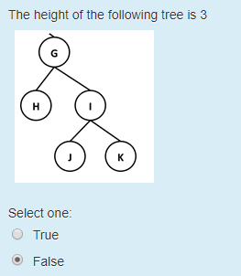

A heap is not a binary tree

Select one:

True

False

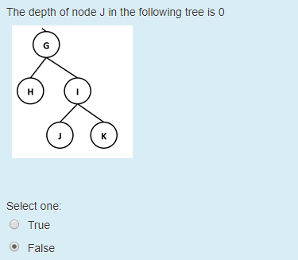

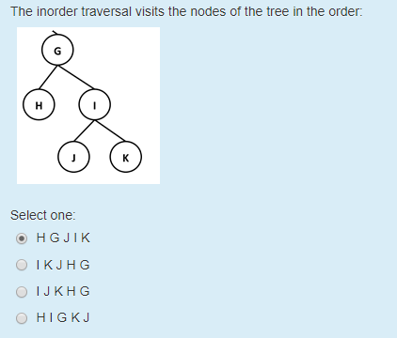

A complete binary tree is always a proper binary tree

Select one:

True

False

In the array representation of a binary tree where the root element is stored at index 1. The right child of a node at index i is at position

Select one:

2i-1

2i

2i + 1

i

Height of an internal node in the tree is

Select one:

one minus the maximum height of its children

one plus the maximum height of its children

one plus the minimum height of its children

always 0

In a complete binary tree, all levels except the last level are completely (maximally) filled with nodes and in the last level, nodes are filled from right to left.

Select one:

True

False

While deleting an element from a heap, Up-heap bubbling is used to restore the heap order property

Select one:

True

False

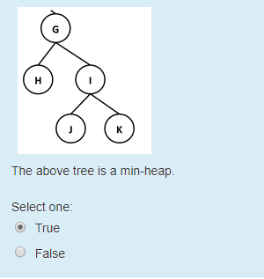

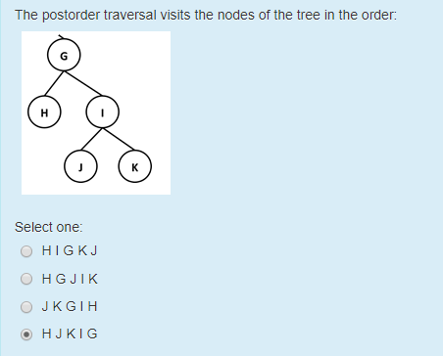

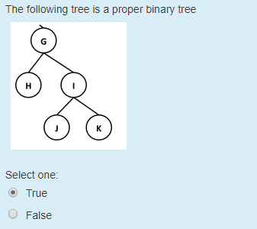

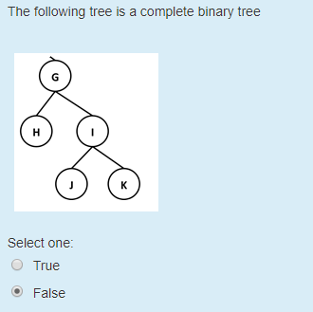

The maximum height h of a binary tree with n nodes is

Select one:

1

n

n-1

h

The time taken to insert an element into a heap is O(log n)

Select one:

True

False

Depth of the root node is

Select one:

two more than the depth of its children

0

1

one more than the depth of its children

Up-heap bubbling can stop at

Select one or more:

the root

any  leaf

an internal node where the heap order property is satisfied

an internal node where the heap order property is not satisfied

The preorder traversal visits the nodes of the tree in the following order

Select one:

Root, Left, Right

Left, Root, Right

Left, Right, Root

Right, Root, Root

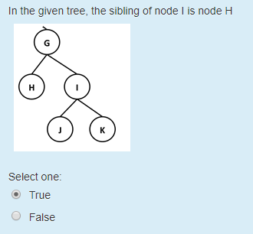

The minimum number of external nodes in a binary tree T of height h is n

Select one:

True

False